Project Design Phase
Solution Architecture
Date | 15 February 2025
Team ID
Project Name
Maximum Marks | 4 Marks

Solution Architecture:
Solution architecture for AI Weather Wise defines how the different technologies, data sources, AI components, and user interfaces work together to provide accurate weather forecasts and timely alerts. Its goals are to:
● Identify suitable technologies and data sources to collect, process, and analyze real-time and historical weather information.
● Define the structure and working of AI Weather Wise, including weather-data collection, data processing, AI-based prediction, alert generation, and user interaction.
● Define the key features and requirements of the system, such as weather forecasting, real-time updates, extreme-weather alerts, location-based information, and personalized recommendations.
● Specify the development and implementation requirements for integrating weather APIs, AI/ML models, databases, backend services, and the web/mobile interface.
● Ensure that weather information is delivered clearly and efficiently to users so they can make better decisions about travel, outdoor activities, farming, and safety.

Example - Solution Architecture Diagram:
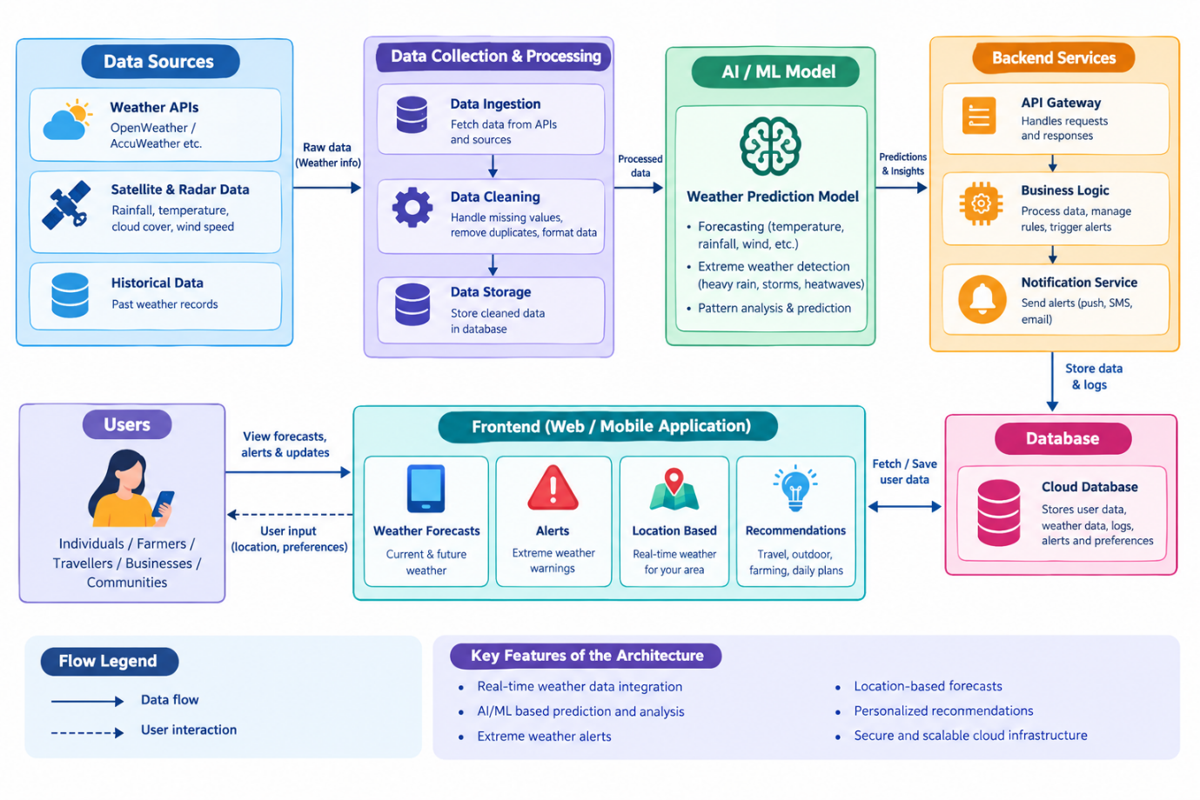
Figure 1: Architecture and data flow of the voice patient diary sample application

